**COHS-logo.eps** 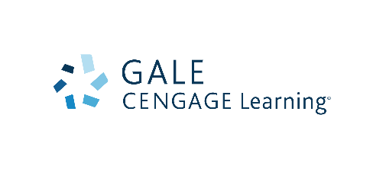

**How it Works**

**Learn About the Program**

Explore this website in depth to learn about the Career Online High School program and how it works. We encourage you to make the decision that is right for you. Research all of your options so that you can make an informed decision. If you determine that earning an accredited high school diploma while gaining real-world career skills is the best option for you, take the self-assessment, which includes an essay question, to proceed with applying to Career Online High School.

**Complete the Online Self-Assessment**

This[**online self-assessment**](http://www.careeronlinehs.gale.com/sac/self-assessment) will ask a series of questions about things like your access to a computer, how much time you can dedicate to coursework and includes an essay question. Those who meet the minimum requirements of the self-assessment will be contacted by the library within 5 business days to discuss the prerequisite course.

Applicants who do not meet the requirements will be contacted and directed toward other programs available to support your educational and career goals.

**Enroll In and Complete a Prerequisite Course**

First, you must select a career major **(there are 8 options)** and enroll in Part 1 of the program (the prerequisite course).

During the prerequisite course, you will:

* Explore the online learning environment to determine if you are comfortable with this instructor-supported, self-paced approach to learning. **The prerequisite course must be completed with a 70% or higher and within two weeks or sooner.**
* Assess whether the Career Online High School program best meets your educational needs, or if alternative options for high school completion are more appropriate.
* Determine if the career field is interesting/appealing.
* Demonstrate to the library your commitment to furthering your education through the successful completion of the full Career Online High School program.

**Scholarship Award Process**

Those who successfully complete the prerequisite course with a 70% or higher within two weeks or less will be eligible for a scholarship award. Prospective students will be contacted by the library within 5 business days to discuss their application into the program and to schedule an interview at the library. A determination will be made regarding scholarship award by the library’s enrollment team within 5 business days after the interview.

**Please note:** Upon scholarship award, you must request transcripts from any accredited high school you’ve attended in order for Career Online High School to determine whether you will receive credit for any previously completed coursework.

**Completing Coursework and Graduating from Career Online High School**

Get Started

Once awarded a scholarship, Career Online High School will pair you with an academic coach, who will welcome you and help you prepare to succeed in the program.

* Virtual Welcome Kit shows you step-by-step how the program works.
* Welcome phone call kicks off a virtual tour of the online campus, which serves as a first-day-of-school orientation.

Go to School

Log-in to your online classroom via the Online Instruction Center. The learning management system includes:

* Anytime access to courses
* Instant feedback on lessons and exams
* Tools to keep track of progress such as Gradebook and Pace Guide
* Online learning resources including eLibrary, calendar, and academic support services
* Pace guide helps you stay on track and move through the program by completing one course credit every two weeks

Get Support

A full support team is dedicated to helping you:

* Academic coach is there to support you via phone, email, and other social networking tools
* Qualified, certified instructors provide academic support
* Support staff helps you plan for their next career steps
* Technical support is available by phone or email

Prepare for a Career

Career readiness is the key to your success:

* Career-focused, skills-based elective courses
* Biweekly online seminars focused on 21st century skills
* Monthly career webinars to prepare you for workplace realities and job markets
* Career portfolio lessons that teach business writing and help you create resumes and cover letters

Graduate

Complete the program fully prepared to be successful in your career and in life.  You graduate with:

* Private high school diploma
* Career certificate
* Career portfolio
* Applicable job prepration training and skills