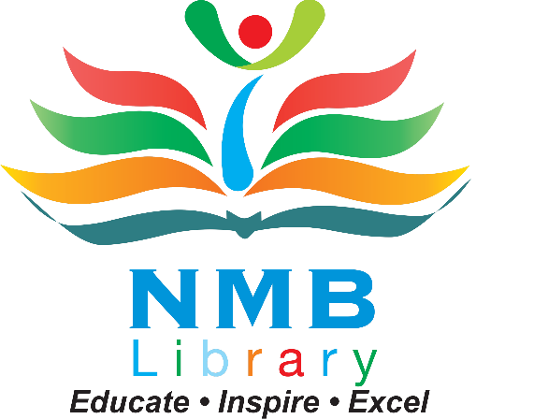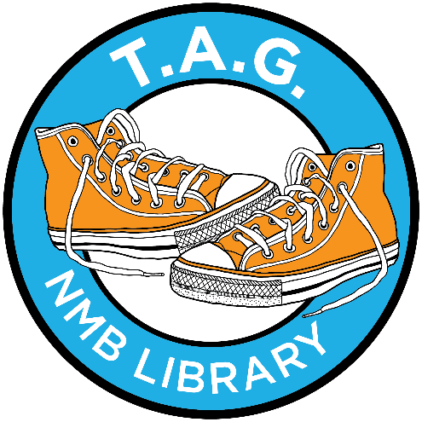

North Miami Beach Library Teen Advisory Group (TAG)
The North Miami Beach Library is creating a Teen Advisory Group (TAG) made up of teen volunteers (ages 13-19) who are interested in being part of the library's programs and services aimed at teen audiences.
WHAT WE DO?
The TAG's goal is to promote library services to teens and the community at the North Miami Beach Library by:
- • Advising, planning and implementing teen programs.
- • Tutor elementary students in Math and/or Reading.
- • Register children for Summer Reading Program
- • Promoting ideas, reading, programming and expression by and for teens by creating displays in the North Miami Beach area.
- • Suggest books and help create booklists for the young adult section.
HOW MUCH TIME COMMITMENT IS REQUIRED?
- • TAG will meet twice a month at the library.
- • TAG participates in library programs, volunteer their time to work on special projects, and help make sure that teen-focused events and programs at the library run smoothly.
WHAT DO I GET OUT OF IT?
- • Having a say in materials and programs for the teens at North Miami Beach Library.
- • Opportunity to be creative and expressive through art and imaginative activities.
- • Personal satisfaction in serving your community and peers.
- • Something creative and fun to do!
- • Community service looks good on college applications and job applications.
HOW DO I BECOME A MEMBER?
The library is currently taking applications to be a Teen Advisory Group Member for a term of 1 year. It doesn't matter what school you attend -- private, public or home school. We want ideas and input from every part of North Miami Beach to help make our teen events the best!
If you are interested in participating in the TAG, complete the application and submit at the front desk.
Teen Advisory Group – North Miami Beach Library 1601 NE 164th St, NMB, FL 33162
If you have questions or need more information, contact Mr. Patrick at (305) 948-2970 or Patrick.blanchard@citynmb.com
Please print.
Teen Advisory Group Application
Last Name: First Name:
Address:
Age:
Date of Birth:
Phone #:
Email Address:
School: Grade:
Library Card Number:

Emergency Contact
Name: Relationship:
Cell: Work Phone:

1601 NE 164th St, NMB, FL 33162 www.nmblib.com 